Note:-

* Do all the following steps with your IP and not whats given in images
* Let the port be 8080 (we are not using 8000 which is default)
* You need to do these steps every time your IP address changes i.e. when you reconnect to your WIFI

1) Find IP address of host machine

Run ipconfig in cmd

Note down IPv4 address

Eg mine looks like this :- 192.168.0.105

Note this depends on router can you need to do this everytime you reconnect to wifi

2) allow chrome to record mic on insecure connection i.e http

By default chrome does not allow usage of mic over http. To allow this follow instructions in this pic

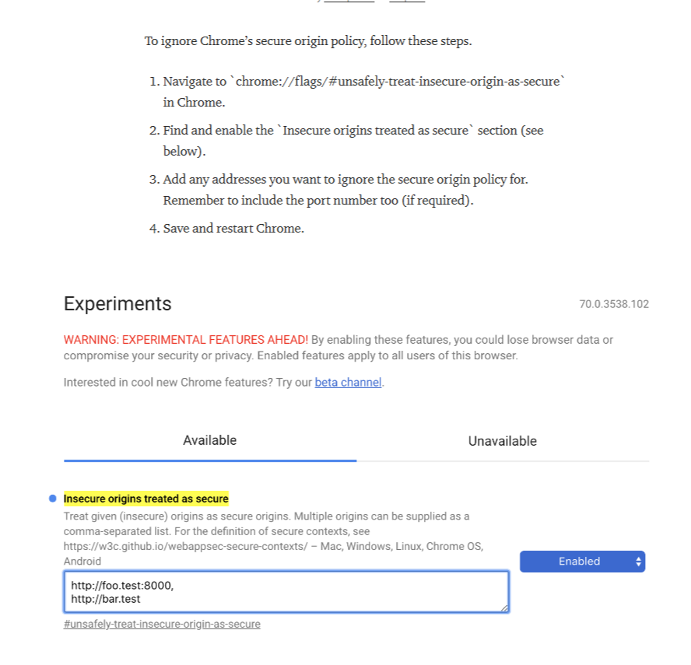

3) Enter IP as allowed host

In settings.py of Django enter you ip as allowed host

Eg 

5) run prog at your IP

Run following command on cmd

Remember to put your IP

Let the port be 8080

